

PRACTICAL GUIDELINES FOR SITE PERSONNEL

CONCRETE PROTECTION
In the fresh state, concrete is vulnerable to damage from a variety of factors such as moisture, temperature changes, and external forces. Therefore, it is essential to take certain precautions to protect the concrete during this period to ensure its strength and durability.
Here are some guidelines for protecting concrete in the fresh state:
- Cover the concrete with a plastic sheet or tarpaulin immediately after pouring to prevent moisture loss due to evaporation. This will help to maintain the required moisture content in the concrete, which is critical for proper curing.
- Protect the concrete from extreme temperature changes by providing shade or covering the surface with insulating material. High temperatures can cause rapid evaporation of moisture, which can result in cracking and reduced strength.
- Use proper curing methods such as water curing, membrane curing, or curing compounds to maintain the moisture content and temperature of the concrete. Curing should continue for at least seven days to ensure that the concrete reaches its design strength.
- Avoid overworking the concrete during placement and finishing, as this can cause segregation and weaken the surface.
- Protect the concrete from external forces such as foot traffic, equipment, and construction materials. Use warning signs and barricades to prevent accidental damage.
By following these guidelines, you can ensure that the concrete remains strong and durable in the fresh state, and minimize the potential for damage and defects that can affect the final product.

CONCRETE FINISHING

Once the concrete has been placed and levelled, the next step is finishing. Finishing refers to the processes that are used to create a smooth, flat surface on the concrete, and to achieve the desired appearance and texture. Here are some common steps involved in finishing concrete:
- Screeding: This is the process of levelling the surface of the concrete using a screed board. The screed board is used to push and pull the excess concrete from high spots to low spots, creating a level surface.
- Floating: Once the surface is levelled, a tool called a bull float is used to smooth the surface and fill any small voids or imperfections. Floating also helps to bring up some of the cream (the cement and water mix) to the surface, which will later be used to create a more durable surface.
- Edging: After floating, the edges of the concrete are shaped using an edging tool. This creates a rounded edge, which not only looks better but also helps to prevent chipping and cracking.
- Jointing: Control joints are created in the concrete to prevent cracking due to thermal expansion and contraction. Jointing is done using a grooving tool to create straight lines in the surface of the concrete.
- Broom finishing: Finally, a broom is used to create a non-slip surface on the concrete. This is done by dragging a stiff-bristled broom across the surface of the concrete while it is still wet.
- Curing: After finishing, the concrete must be allowed to cure. This involves keeping the surface moist for a period of time to allow the concrete to reach its maximum strength.
By following these steps, you can achieve a smooth, durable and attractive finish for your concrete surface.

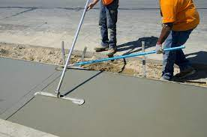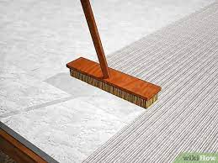
CONCRETE CURING
Curing is the process of maintaining adequate moisture levels and temperature within the concrete to ensure that it reaches its maximum strength and durability. Curing is critical in preventing further loss of moisture from the concrete, which can result in cracking and reduced strength. Here are some methods for curing concrete to prevent further loss of moisture:
- Water curing: This is the most common method of curing concrete. It involves keeping the surface of the concrete continuously wet for a period of time using a hose, sprinkler system, or other method. The surface should be kept wet for at least seven days to allow the concrete to achieve its design strength.
- Membrane curing: This method involves placing a plastic sheet or membrane over the surface of the concrete to prevent moisture loss. The membrane should be kept in place for at least seven days to allow the concrete to cure properly.
- Curing compounds: Curing compounds are chemical coatings that are sprayed onto the surface of the concrete to prevent moisture loss. These compounds form a film on the surface of the concrete, which helps to retain moisture and prevent the concrete from drying out.
- Wet coverings: Wet coverings, such as wet burlap, can be used to cover the surface of the concrete to prevent moisture loss. These coverings should be kept wet for at least seven days to allow the concrete to cure properly.
- Steam curing: This method involves using steam to raise the temperature of the concrete and accelerate the curing process. Steam curing is often used in precast concrete applications, where time is critical and curing must be completed quickly.
By following these methods of curing, the concrete can reach its maximum strength and durability, and prevent the further loss of moisture from the concrete, which can result in cracking and reduced strength.
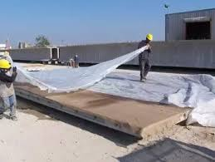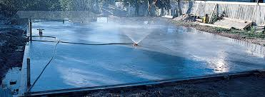

GUIDELINES TO CURING

Curing is an essential process for achieving strong and durable concrete. Proper curing helps the concrete to reach its maximum strength, prevents cracking, and ensures that the surface remains attractive and functional. Here are some guidelines for curing concrete:
- Start curing as soon as possible: The curing process should start as soon as the concrete has been placed and finished. Delaying curing can result in cracking and reduced strength.
- Keep the surface moist: The surface of the concrete should be kept moist for a minimum of seven days. This can be done using various methods such as wet coverings, water curing, or curing compounds.
- Maintain a consistent temperature: The temperature of the concrete should be maintained within a specific range during the curing process. This helps to ensure that the concrete cures evenly and achieves its maximum strength.
- Protect the surface: The surface of the concrete should be protected from external factors such as foot traffic, equipment, and construction materials. Use warning signs and barricades to prevent accidental damage.
- Avoid rapid temperature changes: Rapid changes in temperature can cause cracking in the concrete. Therefore, it is essential to provide shade or covering the surface with insulating material to prevent rapid changes in temperature.
- Use appropriate curing methods: Choose the most appropriate curing method based on the specific project requirements and conditions. Water curing, membrane curing, curing compounds, and steam curing are some of the most common methods used for curing concrete.
By following these guidelines, you can ensure that the concrete cures properly, reaches its maximum strength and durability, and remains attractive and functional over time.

